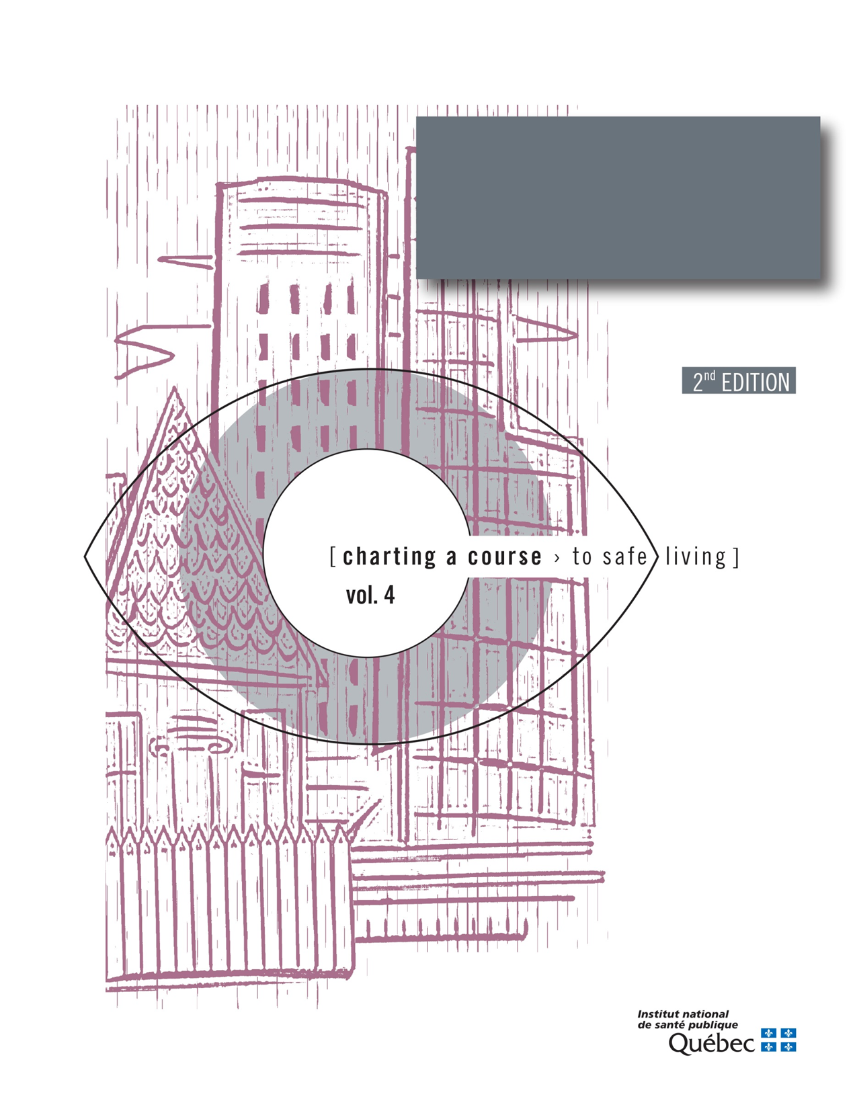

Guide to Analysing Spousal Violence withing a Region
Appendix 6

Table 10. How the study area compares to Québec as a whole with regard to the factors associated with spousal violence
Factors | Favourable trend | Québec average | Unfavourable trend
Unemployment
Income
Level of education
Social support
Heavy alcohol consumption
Physical health
Mental health
Child maltreatment
Delinquency
Crime and violence in communities

Favourable trend: The value of the indicator for the study area is below that for Québec as a whole.
Québec average: The value of the indicator for the study area is comparable to the Québec average.
Unfavourable trend: The value of the indicator for the study area is above that for Québec as a whole.

Note: Certain statistical tests can be conducted to determine if the difference observed between the study area and Québec as a whole is statistically significant; that is, whether the difference is real or due to chance. It is preferable to contact a statistician for this purpose.

